A guide on how to avoid getting friend-zoned

## Does it seem like every girl you talk to or hang with usually leads to a friend and nothing more, and you are sick of it? Sure you are doing something wrong, and you need to fix the way you deal with girl, Once and for all

**Version:1.0**

## http://pad1.whstatic.com/images/thumb/a/ae/Escape-the-Friend-Zone-Step-5.jpg/550px-Escape-the-Friend-Zone-Step-5.jpg

## Reasons for getting friend-zoned

* Being so nice.
* Being a good listener and a shoulder to cry on.
* Being guy that girls say they want.
* Being a friend
* Trying so hard.

**The Nice guy problem**

being nice may seem like helping you to get near the girl you want but it is actually doing you the exact opposite, it has been proven that girls NEVER CONSIDER nice people as anything more than friends, that is because being nice with a girl automatically makes her lose her curiosity about you and makes her consider you a faithful friend. If some girl is like 'aww i had a bad day'...and if there is any hint of a reason for you to believe she is just looking to rant on someone... DONT BE THAT GUY. Just poke fun at her. Obviously be sensitive enough not to take it TOO far or else she might just start hating you.



**[RULE]** being nice won’t get you anywhere, try being a bi**h but done exaggerate or she might hate you.

**The good listener trap.**

Don't listen to their problems, a lot of girls just like venting to anyone who will listen, if you keep listening to them and offering advice you have become their personal therapist, and nothing more, you will find that you have become their shoulder to cry on and ask for advice whenever they fall into problems. If you feel like you are getting into that, stop being available all the time, try escaping by either making yourself tired or busy most of the times. Don’t be her shoulder 24/7, she'll lose interest. Girls are just a balancing act. If you act like too much of a neglective dick, they'll lose interest. if you play your cards just right, making yourself a chase and giving them pieces of you little by little, they'll be f*cking obsessed with you.



**[RULE]** being a good listener will make you her free therapist, avoid being the shoulder she goes and cries on whenever she has a problem, always give them pieces of you little by little.

**Don’t Be the guy girls say they want**

Girls don't know WTF they want, whenever you listen to a girl saying "I want this, this, and this in a guy" it's complete, utter bullsh*t. don't ever listen to women for advice on how to pick them up, 95% of the sh*t they tell you is pure bullsh*t. what they want and what actually gets them to f*ck your brains out are 2 completely different things.

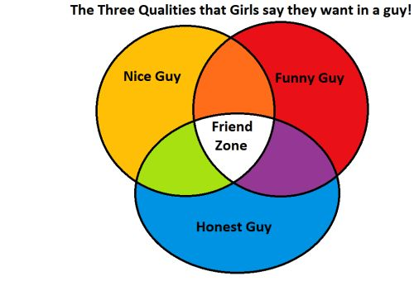

**[RULE]** Girls don’t know what they want so never listen from her about the traits of the guy of her dreams.

**Don’t Be her Friend**

If you don’t want to be treated as a friend, never deal with the girl you love as a friend, if you were her friend and suddenly decided to go for more, then stop being a friend, stop talking like a friend and stop dealing with her like other people do, stop talking with her in a group conversations and you might as well stop hanging with her in a group, the best advice for not getting into the friend-zone is to stop being called a friend in the first place.



**[RULE]** if you don’t want to get friend-zoned, Don’t be a Friend

**Stop trying so hard**

Trying so hard to get a girl will mean one thing and one thing only, you will be taken for granted and the girl will lose curiosity in you, if you are so easy to get why would she consider you, I know this saying is old, but it still works every time, being hard to get still gets amazing results, you will drive her crazy curious and make her hungry to know you more, all her thinking and focus will be upon you and she won’t miss a chance to get to know you more, feeding her the knowledge she is thriving for piece by piece will guarantee you a special place in her mind and zero chance of losing interest and getting friend-zoned or even less. But however, you must practice the hard to get dealing with her well or she might lose hope completely and it will turn on you.



**[RULE]** Be hard to get and make the girl hungry to know more about you, feeding her little pieces of knowledge at atime